Dis-Indo-Borneo-Dayak- Hudok Mask

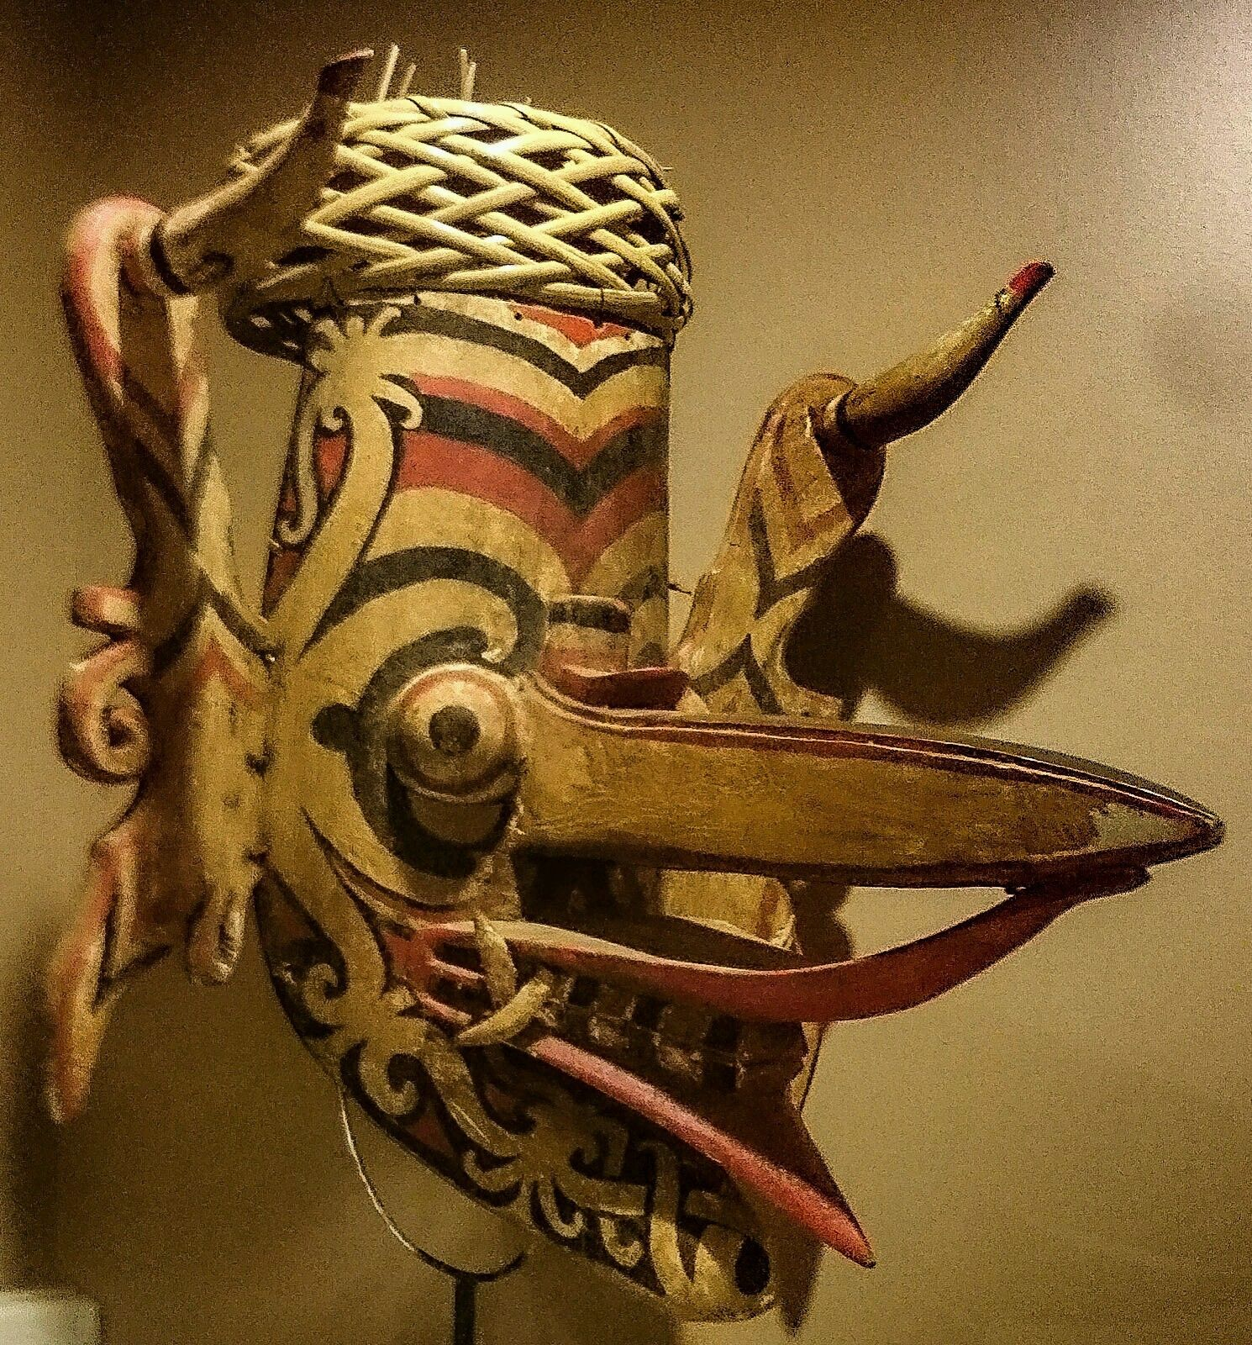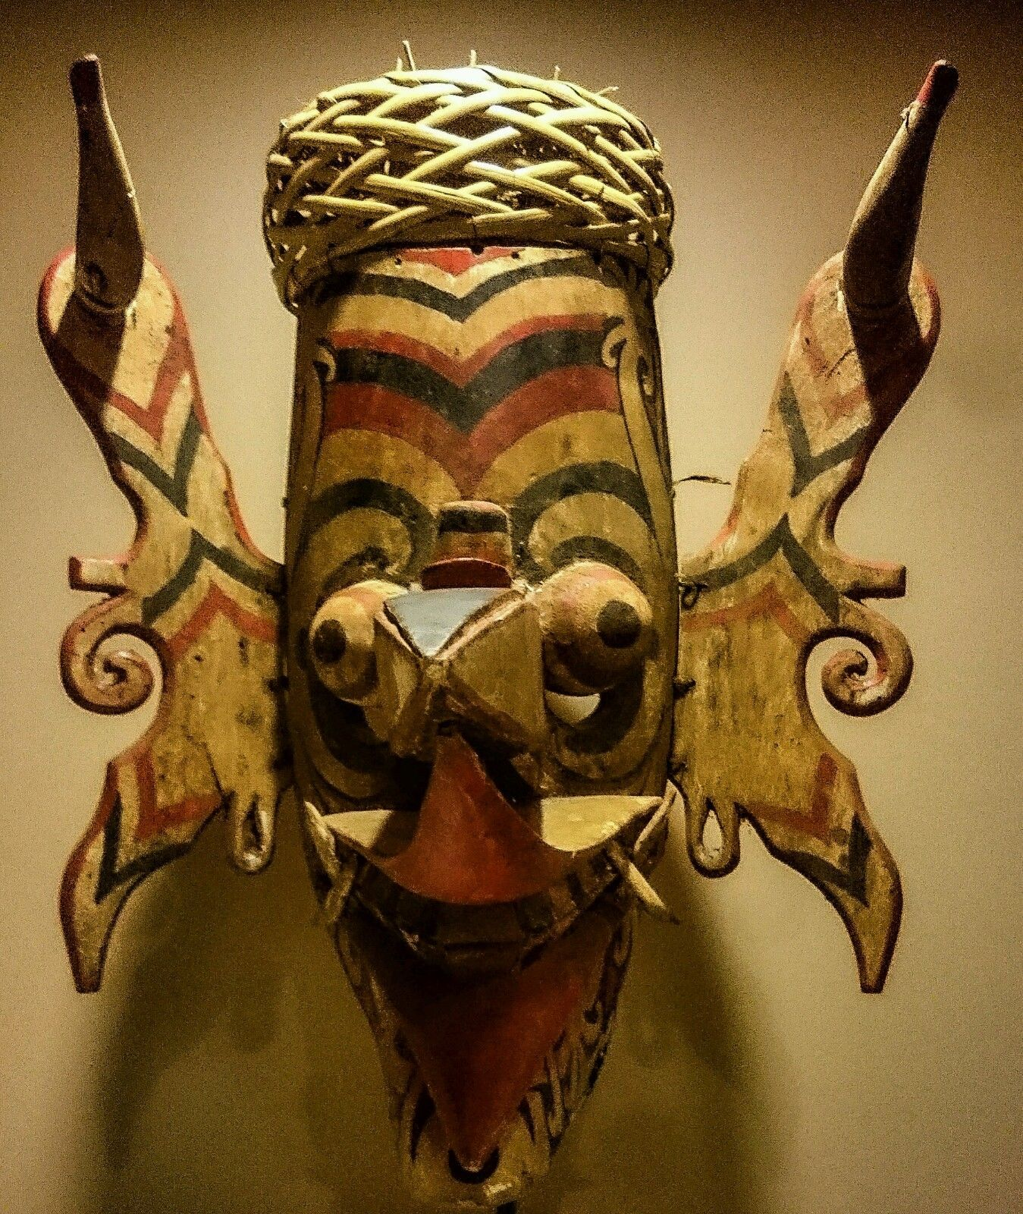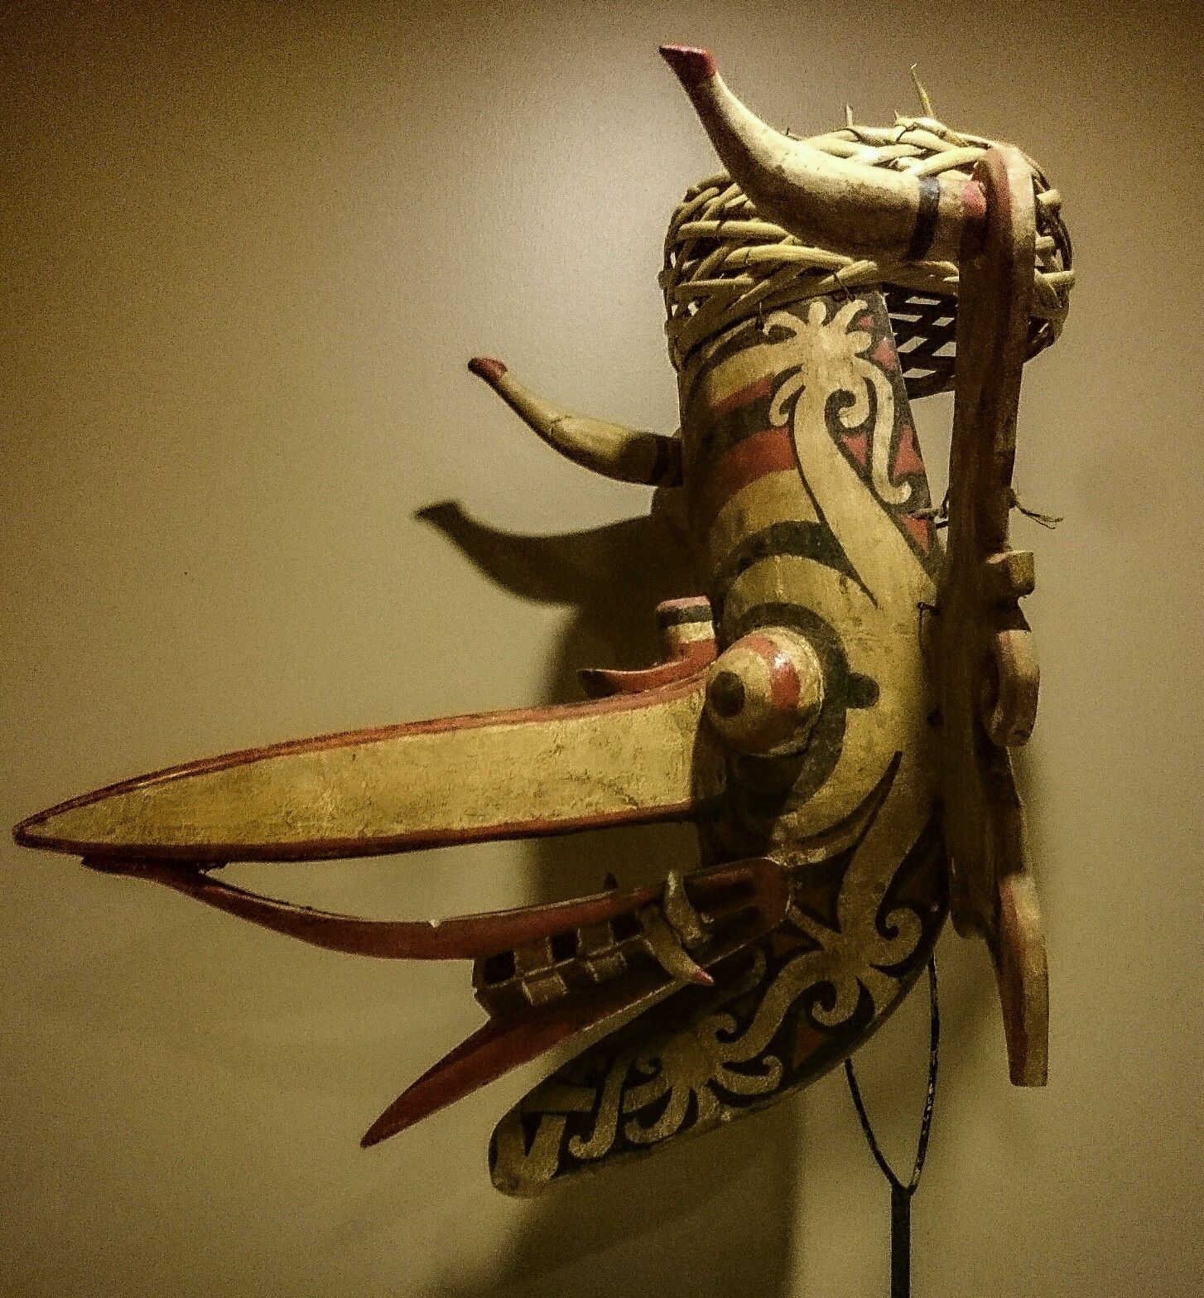

Fig. 1. Borneo, Bahau Dayak People, Dragon-hornbill *Hudoq* Mask, ca 1930

Formal Label: Borneo, Bahau Dayak People, Dragon-hornbill *Hudoq* Mask, ca 1930

Accession Number:

**LC Classification:** DS646.

Date or Time Horizon: 1930

Geographical Area: Borneo, Makaham River

**Map:**

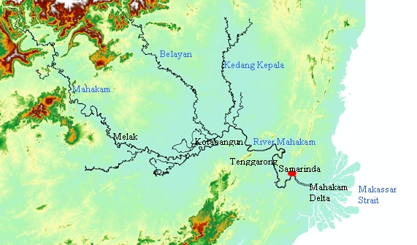

Fig. 2. Map of Mahakam River after [Hidayat008](https://commons.wikimedia.org/wiki/User:Hidayat008) https://upload.wikimedia.org/wikipedia/commons/e/ea/MahakamMap.jpg.

Cultural Affiliation: Dayak

Media: Polychrome (Red, Black and White) Pigments, Wood, Rattan.

Dimensions: H 43cm ; W 38cm.  
Weight:

Condition: The example here is in an excellent, stable condition with no losses or repairs. It has a patina consistent with an early twentieth century dating.

Provenance: private collection, UK.

**Discussion:** This mask is from a Dayak Bahau kampung (village), on the upper Mahakam River region of Borneo.It is of light wood and represents a composite dragon-hornbill spirit. It would have been worn by a dancer at planting, harvest and similar festivals. Young male dancers wearing such masks and cloaks would enter the village at important times connected with the rice growing cycle and would impersonate the spirits who have come down to earth to bless the harvest, a ritual known as the *Hudoq*. Apertures just below the mask's 'eyes' allowed the dancer to see.

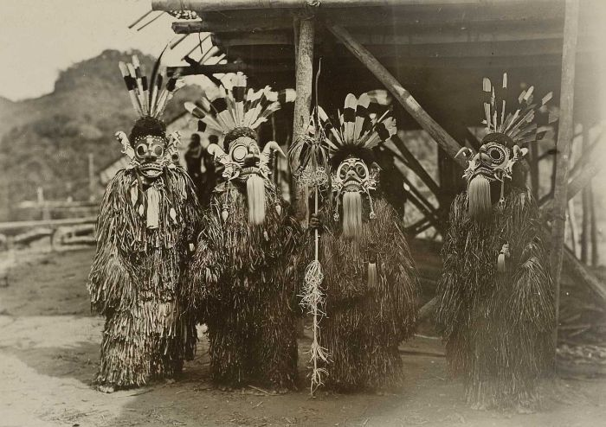Fig 2. A group of *Hudoq* dancers by J. (Jean) Demmeni, photographer, during the Mask dance sowing celebration of the Bahau Dayaks, Upper Mahakam River Region. This picture was taken during the Commission's Trip to Central Borneo A. W. Nieuwenhuis, 1898-1900. From the Tropenmuseum in Amsterdam, part of the National Museum of World Cultures, CC BY-SA 3.0, https://commons.wikimedia.org/w/index.php?curid=8595445

This mask comprises a central head element with ears attached by means of rattan ties and a woven rattan basket cap. Related examples are illustrated in Barbier (1984, p. 80), Maxwell (2010, p. 89), Hardianti & ter Keurs (2005, p. 99), Miksic (2007, p. 226), Capistrano-Baker (1994, p. 32), and Meulenbeld *et al* (1988, p. 125). The mask is painted in cream, red and black polychrome. A protruding mouth has expertly carved mouth and protruding fangs. The large floppy ears have projecting tiger-cat tusks. The eyes are semi-spherical and bulging with black pupils. The prominent beak juts out almost horizontally. The lips are exaggerated and protrude over the teeth.  
 The mask was worn by fitting the basket cap with hornbill feathers (which are not present because they are illegal to export) over the dancer's head allowing the mask to hang over the dancer's face. Masks in museum collections often no longer retain their woven rattan caps, unlike this example, which shows it has actually been used in *Hudoq* dances. In the dance "The young men are completely transformed into hairy creatures with fiber cloaks, with large eyes, gigantic fangs, and huge ears ornamented with tiger-cat tusks appropriate for a spectacle depicting the frightful aspect of these powerful spirits" (Nieuwenhuis 1904: 325). The dazzling and incredible profiles of masks like the one here sprout great snouts and fabulous ears and piercing demon eyes to produce a supreme spectacle of wonder and amazement. The purpose of the dance is not only to protect the rice from predators but also to awaken the farmers to their duties of overseeing the rice patties.

Yet, there is another side to this Hudoq dance: an ancient ritual of catching lost rice spirits. This is central to the concept of animism that the energy, or life, in an object comes from a spiritual component, the anima. Sarah Gill (1967) has offered the suggestion that the Dayak dances and rituals originated in South-east Asia, and indeed, there, too, the rice plant was believed to be animated by a spirit or soul. This parallels the animism behind the *Hudoq* dances in Borneo. Furthermore, these Bahau Dayaks of the Upper Mahakam River Region speak Kayan Mahakam, an Austronesian language, and, therefore, represent one of the Austronesian ethnic groups of Maritime Southeast Asia who had emigrated to the southern Philippines and then into Indonesia. Should the soul be lost, the rice would die: so these same fabulously masked *Hudoq* dancers clad in their hairy cloaks enter the rice paddies behind their leader who, with his *krawit bruwa* or soul-catching hook, seeks lost rice spirits and with his hook snares them from oblivion (Nieuwenhuis 1904: 32).  
   
  
***References****:*Barbier, J.P., *Indonesian Primitive Art, Dallas Museum of Art*, 1984.  
Capistrano-Baker, F.H., *Art of Island Southeast Asia: The Fred and Rita Richman Collection in the Metropolitan Museum of Art*, The Metropolitan Museum of   
Art, 1994.  
Hardianti, E.S. & P. ter Keurs (eds.), *Indonesia: The Discovery of the Past*, KIT Publishers for De Nieuwe Kerk, Amsterdam, 2005.  
Maxwell, R., *Life, Death & Magic: 2000 Years of Southeast Asian Ancestral Art*, National Gallery of Australia, 2010.  
Meulenbeld, B.C., *et al*, *Budaya Indonesia: Arts and Crafts in Indonesia*, Tropenmuseum, 1988.  
Miksic, J., *Icons of Art: The Collections of the National Museum of Indonesia*, BAB Publishing, 2007.  
Sellato, B. (ed.), *Plaited Arts from the Borneo Rainforest*, NIAS Press, 2012.